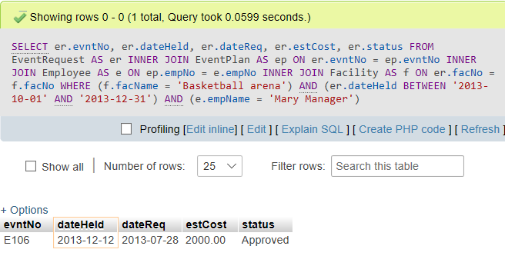

SELECT

er.evntNo,

er.dateHeld,

er.dateReq,

er.estCost,

er.status

FROM EventRequest AS er

INNER JOIN EventPlan AS ep ON er.evntNo = ep.evntNo

INNER JOIN Employee AS e ON ep.empNo = e.empNo

INNER JOIN Facility AS f ON er.facNo = f.facNo

WHERE (f.facName = 'Basketball arena') AND (er.dateHeld BETWEEN '2013-10-01' AND '2013-12-31') AND

(e.empName = 'Mary Manager');